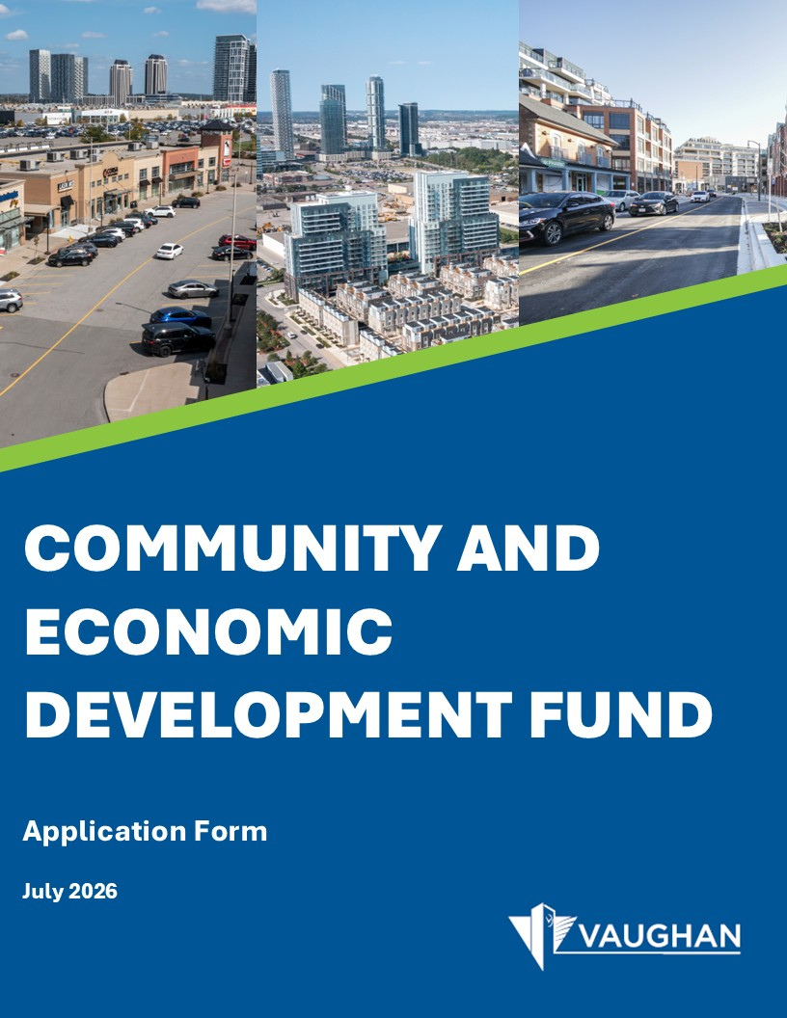

Financial Incentives Application Form
Month, 2026

Application Form Contents

Application Background 2
Applicant Information 2
Primary Contact 2
Property Information 3
Project Information 4
Development and Building Permit Applications 5
Declaration of Landowner or Agent 6
Authorization of Agent 7
Permission to Enter 8
Submission Checklist 9

Application Background
Please refer to the Community Improvement Plan for Non-Residential Development and Complete Communities, and the Efficient Movement of Goods and Talent (“Community Improvement Plan”) for detailed information on each financial incentive program, eligibility criteria, and application requirements. The Community Improvement Plan is available at vaughanbusiness.ca/invest.

Submit the completed application form along with all required supporting documentation to the online submission portal at vaughanbusiness.ca/invest.

If you have any questions, please contact the Economic Development Department at ed@vaughan.ca.

Applicant Information
 | Applicant* | Registered Owner of the Property
Company Name
Contact Name
Mailing Address
Phone Number
Email Address

Applicant is:

☐Registered Owner
☐Agent
☐Tenant
☐Other (please specify): _________________________________
*An owner’s authorization form is required if the applicant is not the owner.

Date of pre-application consulting meeting with the Implementation Committee (if applicable):

__________________________________________

Primary Contact
Please indicate the primary contact for all correspondence related to this application:

☐Registered Owner
☐Agent
☐Both
☐Other (please specify): _________________________________

Property Information
Municipal address of the property: ____________________________________________________

Legal description of the property: ____________________________________________________________________________________________________________________________________________________________________________________________________________________________________________________________________________________

Current Official Plan Designation: ____________________________________________________________

Current Zoning Category: ____________________________________________________________________

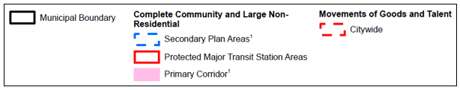
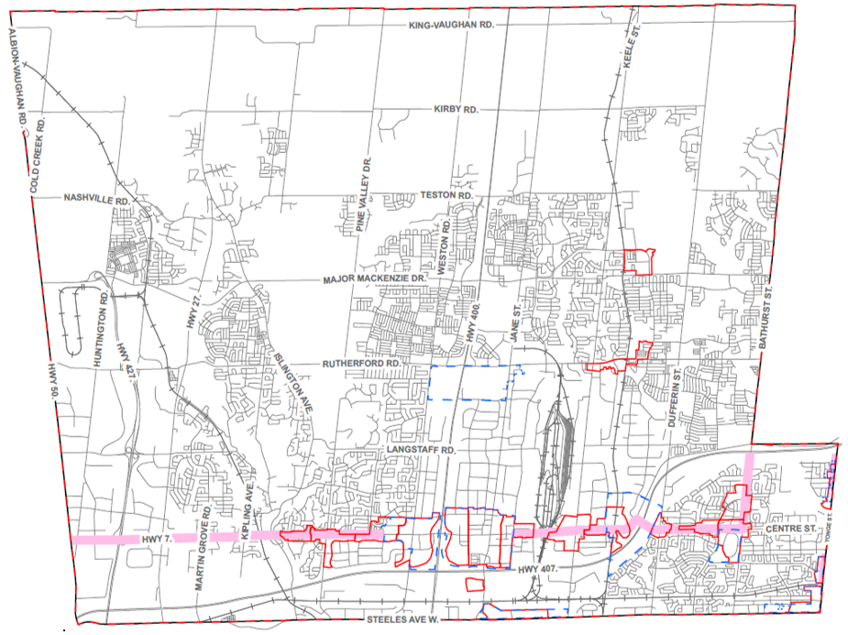
Is the property within the boundary of the applicable Community Improvement Plan area, specifically ‘Complete Community and Large Non-Residential Area’? To check, refer to the map below.

☐Yes ☐No
Are there any outstanding work orders on this property?

☐Yes (please specify) _________________________________________________________

☐No

Are property taxes in good standing on this property? ☐Yes ☐No

Project Information
Please select the financial incentive program(s) for which you are applying.

Please note that the incentive programs currently available in Phase 1 (2026 – 2030) are noted below.

Applicants may be eligible to receive more than one incentive program (stacking incentives), subject to program criteria and restrictions outlined in Section 5.1 General Eligibility Criteria of the Community Improvement Plan.

For more information on each incentive program, please refer to the Community Improvement Plan at vaughanbusiness.ca/invest.

✓ | Financial Incentive Program | Eligible Funds Per Project | Estimated Total Cost of Project | Amount Requested for this Application**
Complete Communities and Non-Residential Development
 | Major Office Development Charges Deferral | - A deferral for new major office developments:  - 75,000 sq. ft. – 149,999 sq. ft.: 50% deferral until change of use.  - 150,000 sq. ft. – 249,999 sq. ft.: 75% deferral until change of use.  - 250,000 sq. ft. – 600,000 sq. ft.: 100% deferral until change of use.  - Incentive is capped at 5-years or a maximum of 600,000 sq. ft. | n/a | n/a
 | Convention Centre Development Charges Deferral | - A deferral for up to ten years for a new convention centre that includes a minimum of 90,000 sq. ft. of contiguous exhibition hall space.  - Incentive is capped at 5-years or a maximum of 90,000 sq. ft. | n/a | n/a
 | Interim Use Activations (Retail or Recreational) Grant | - A capital grant up to 80% of fees incurred for the physical infrastructure costs required to support the use, to a maximum of $50,000 per project.  - Incentive is capped at $250,000 or five projects.
**The amount requested will be considered and allocated based on evaluation by the Implementation Committee. The maximum amount may not always be available or applied to each awarded project.

Provide a detailed description of the proposed project, including the nature of the project (e.g., type and form of use/activity, building size, number of storeys).

________________________________________________________________________________________________________________________________________________________________________________________________________________________________________________________________________________________________________________________________________________________________________________

Development and Building Permit Applications

Building Permit Applications*** Please fill out this section for applications for the following financial incentives:
- Major Office Development Charges Deferral
- Convention Centre Development Charges Deferral
- Interim Use Activations Grant

Projects are only eligible for financial incentives if building permit issuance has not been received.

Did the property receive building permit(s) related to the financial incentive program selected in Section 5 of this application form?

​☐​Yes ​☐​No

Declaration of Landowner or Agent
I, ________________________________(name) of the _________________________________ (City/Town) in the ___________________________(Region) solemnly declare that all of the statements contained in this application and supporting documents are true, and I make this solemn declaration conscientiously believing it to be true and knowing that it is of the same force and effect as if made under oath and by the Canada Evidence Act.

Declared before me at the _____________________________(City/Town) in the ____________________(Region) this __________ (date) day of _____________ (month), 20____(year).

__________________________________________
Signature of Owner/authorized signing officer or Agent

__________________________________________
Location of Commissioner of Oath’s Stamp and Signature

Agreement and Acknowledgement regarding the collection and disclosure of information

As the registered property Owner, I agree and acknowledge that personal information on this form and any documentation provided in support of the application are collected under the legal authority of the Planning Act, R.S.O. 1990, Chapter P.13 (as amended) and Regulations thereto. Information collected as part of this application (including this form and supporting documents) is considered to be a public record under the Municipal Freedom of Information and Protection of Privacy Act, R.S.O. 1990, c. M.56, as amended. This information will be used to process this application. Disclosure of information on the application will be consistent with the Municipal Freedom of Information and Protection of Privacy Act and the Planning Act. Information and material that is required to be provided to a municipality under the Planning Act shall be made available to the public. Questions about this collection and disclosure of information and materials should be directed to the Economic Development Department, 2141 Major Mackenzie Drive, Vaughan, Ontario L6A 1T1 905-832-8585.

Date _________________________ Signed ___________________________________
(Signature of Owner or authorized signing officer)

___________________________________
(Please print name)

Authorization of Agent

(To be signed by Owner, if Agent has been appointed.)

As of the date of this application, I am the Registered Owner of the lands described in this application, and I have examined the contents of this application and hereby certify that the information submitted in the application is correct insofar as I have knowledge of these facts, and I authorize the submission of this application on my behalf of:

___________________________________________ whom I have appointed as my Agent.
(Please print name of agent)

Date _________________________ Signed ___________________________________
(Signature of Owner or authorized signing officer)

___________________________________
(Please print name)

Affix the corporate seal of the registered owner of the property, if the registered owner is a corporation. Processing will not commence until this is provided.

Permission to Enter

I ___________________________________ (name), being the Registered Owner of the property at __________________________________________________________________(address/legal description) which is subject to this application, hereby authorize City of Vaughan staff, agents, contractors and consultants to enter upon the above-noted property for the purposes of making inspections associated with this application, during normal and reasonable working hours.

Date _________________________ Signed ___________________________________
(Signature of Owner or authorized signing officer)

___________________________________
(Please print name)

Submission Checklist
Before submitting your application, please ensure you have completed and enclosed all necessary documents. Please submit the completed application form along with all supporting documents to the online submission portal at vaughanbusiness.ca/invest.

☐Completed Community and Economic Development Fund application form

☐All supporting documents required for the incentive program(s) to which you are applying. Details can be found in the Community Improvement Plan at vaughanbusiness.ca/invest.

Major Office Development Charges Deferral
☐Statement of how the proposed project meets the overall goals and objectives of the Community Improvement Plan
☐ A copy of the site development application, approved change of use, if applicable (at building permit stage), and gross floor area
☐Specifications of the proposed project, including design drawings, sketches, renderings, and/or elevation drawings prepared by a qualified professional
☐Any additional requirements or information determined by the Implementation Committee

Convention Centre Development Charges Deferral
☐Statement of how the proposed project meets the overall goals and objectives of the Community Improvement Plan
☐A copy of the site development application, approved change of use, if applicable (at building permit stage), and gross floor area
☐Specifications of the proposed project, including design drawings, sketches, renderings, and/or elevation drawings prepared by a qualified professional
☐Any additional requirements or information determined by the Implementation Committee

Interim Use Activations (Retail or Recreational Use) Grant
☐Statement of how the proposed project meets the overall goals and objectives of the Community Improvement Plan
☐Well-composed photographs of existing condition of buildings/ property
☐Historical photographs and/or drawings where available
☐Building permit if applicable and a copy of the site development application, approved change of use, if applicable (at building permit stage), and gross floor area
☐Specifications of the proposed project, including design drawings, sketches, renderings, and/or elevation drawings prepared by a qualified professional
☐At least two cost estimates for eligible work provided by a licensed contractor or consultant, as appropriate in the context of the financial incentive program
☐A detailed budget for the work
☐Statement identifying how the use will drive foot traffic, contribute to community vibrancy, and how success will be measured, outlined in a Letter of Commitment that is signed by a qualified professional if it pertains to technical information or signed by the applicant if it is descriptive information
☐Any additional requirements or information determined by the Implementation Committee

